USB Secrets
Flag: PacketCapture{DEVICE_HISTORY}
Category: Digital Forensics
Tools used: text editor, Python
Steps:
1. Start point: usbstor_export.reg.
- What I found: an export of HKLM\SYSTEM\CurrentControlSet\Enum\USBSTOR with four USB storage devices: a SanDisk Cruzer Blade, a Kingston DataTraveler 2.0, a "Generic STORAGE_DEVICE" and a WD My Passport.
- Thinking: the brief says "most entries look exactly like what you'd expect. One doesn't." Each USBSTOR subkey is "Disk&Ven_<vendor>&Prod_<product>&Rev_<rev>\<serial>&0", so I compared the serial numbers.
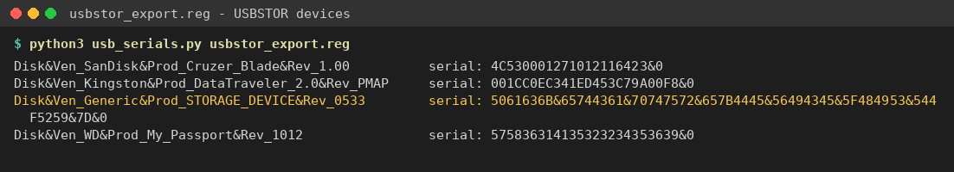
USBSTOR devices and serials; the Generic device serial is chunked hex
2. Pivot: the anomalous serial.
- What I found: the Generic device's serial is 5061636B&65744361&70747572&657B4445&56494345&5F484953&544F5259&7D&0
- Thinking: real serials are one continuous string. This one is split into 8-character chunks by "&", and every chunk is valid hex. It starts with 50 61 63 6B, which is "Pack" in ASCII. A comment in the export also flags it: "serial number does not match any known vendor format".
3. Decoding.
- What I did: removed the "&" separators and the trailing "&0" instance suffix, then hex-decoded the rest.
- Result: Pack | etCa | ptur | e{DE | VICE | _HIS | TORY | } = PacketCapture{DEVICE_HISTORY}
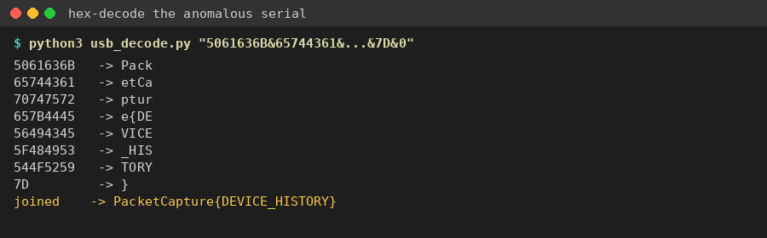
Hex-decoding the serial chunks
Key insight: know what a normal artifact looks like (vendor, product, rev, serial) so the field that breaks the pattern stands out. Hex that starts with 50 61 63 6B is "Pack", the start of the flag format.

